AI BLOGNEST API

AI-POWERED BACKEND REST API FOR INTELLIGENT BLOG CONTENT GENERATION AND SEARCH

PROJECT DOCUMENTATION
Submitted By:
Team ID:SWTID-2026-6999
Team Leader: Ganesh Kumar T
Team Member: Hariharan R
Team Member: Dinesh Karthick V
Team Member: Santhosh M
Course: B.Sc. Computer Science with Artificial Intelligence
College: DRBCCC Hindu College
University: University of Madras
Academic Year: 2026-2027

1. ABSTRACT
AI BlogNest API is an AI-powered backend REST API developed to simplify blog creation, content management, and intelligent content discovery. The application is developed using Node.js, Express.js, MongoDB Atlas, Mongoose, JWT authentication, bcrypt password hashing, and Google Gemini AI.
The system supports four different user roles: Administrator, Editor, Author, and Reader. Each role has specific permissions for creating, viewing, updating, publishing, and managing blog content. The system also provides category management, tag-based filtering, comment management, and comment moderation.
Google Gemini AI is integrated into the application to automatically generate blog content and summarize existing blog content. MongoDB Atlas Search is used to perform keyword-based full-text searching, while MongoDB Atlas Vector Search is used for semantic searching using vector embeddings. This allows users to retrieve conceptually related blog content even when exact keywords are not used.
The application follows a modular MVC architecture. The backend is divided into models, controllers, services, routes, and middleware. Postman is used to test and demonstrate the REST APIs. The system combines conventional backend development with Artificial Intelligence, secure authentication, role-based authorization, and intelligent search technologies.

2. INTRODUCTION
Blogging platforms have become an important method of sharing information, knowledge, opinions, tutorials, and educational content. However, managing large amounts of blog content can become difficult when users need to create articles, organize categories, manage comments, control permissions, and search large collections of content.
Traditional blog management systems usually require authors to manually create content, summaries, and tags. Searching is also commonly performed using exact words or phrases. Such approaches may not always provide efficient content discovery when the user searches using related concepts rather than the exact words present in an article.
AI BlogNest API addresses these challenges by combining backend development with Generative AI and intelligent search technologies. Google Gemini is used for AI-assisted content generation and summarization, while MongoDB Atlas Search and Vector Search provide both keyword-based and semantic search capabilities.
The project is implemented as a backend REST API and can be accessed through tools such as Postman. The BlogNest specification describes a headless backend service in which the API routing layer acts as the interface for client applications.

3. PROJECT TITLE

AI BlogNest API

Project Theme
AI-Powered Backend REST API for Intelligent Blog Content Generation, Management and Search

4. PROJECT DESCRIPTION
AI BlogNest is a secure and intelligent REST API platform designed for blog creation and content management.
The system uses Node.js and Express.js for backend development and MongoDB Atlas with Mongoose for database management. Google Gemini AI is integrated to provide AI-assisted blog generation and summarization.
The application supports four user roles:
- Admin
- Editor
- Author
- Reader
Users can perform operations according to their roles. Authors can create and manage their own blog posts, editors can review and manage content, administrators have complete management privileges, and readers can access published content and participate through comments.
The system also provides search capabilities using MongoDB Atlas Search and MongoDB Atlas Vector Search

5. PROBLEM STATEMENT
Traditional blogging systems present several challenges.

5.1 Manual Content Creation
Writing complete blog articles manually requires significant time and effort.

5.2 Manual Summarization
Long articles require additional time to create concise summaries.

5.3 Content Organization
Managing drafts, categories, tags, publishing statuses, and comments can become difficult when the number of posts increases.

5.4 Permission Management
Different users require different levels of access. Authors should not be allowed to modify another author's content, while administrators require broader permissions.

5.5 Traditional Search Limitations
Keyword-only searching may fail when users search using different words for the same concept.

5.6 Security Issues
Backend applications require authentication, authorization, password protection, request validation, input sanitization, and protection against excessive requests.
The BlogNest case study specifically identifies difficulties involving drafts, categories, tags, content approval, comment moderation, media management, and role-based permissions.

6. PROPOSED SOLUTION
AI BlogNest provides a centralized backend platform that combines traditional content management with Artificial Intelligence.
The proposed system provides:
- Secure user registration and login
- JWT authentication
- Role-Based Access Control
- Blog CRUD operations
- Category management
- Tag-based filtering
- Comment management
- Comment moderation
- AI-powered blog generation
- AI-powered summarization
- MongoDB Atlas Search
- MongoDB Atlas Vector Search
- Semantic search
- Input validation
- Input sanitization
- Rate limiting
- Structured logging
The BlogNest project specifically describes AI-assisted content generation, summarization, content lifecycle management, category/tags, comments, and role permissions
7. OBJECTIVES

7.1 Primary Objectives
- To develop a backend REST API for blog management.
- To implement secure authentication using JWT.
- To implement role-based authorization.
- To provide complete blog CRUD operations.
- To integrate Google Gemini AI.
- To generate blog content automatically using AI.
- To summarize blog content using AI.
- To implement MongoDB Atlas Search.
- To implement MongoDB Atlas Vector Search.
- To implement semantic search using embeddings.

7.2 Secondary Objectives
- To improve content management efficiency.
- To reduce manual content creation effort.
- To provide controlled access to different types of users.
- To improve blog discovery through intelligent search.
- To maintain a secure backend environment.
- To provide a testable and modular REST API.

9. SYSTEM REQUIREMENTS

9.1 Software Requirements
Component | Requirement
Operating System | Windows 10/11, macOS or Linux
Runtime | Node.js
Backend Framework | Express.js
Database | MongoDB Atlas
ODM | Mongoose
Authentication | JWT
Password Security | bcryptjs
AI Service | Google Gemini
Search | MongoDB Atlas Search
Semantic Search | MongoDB Atlas Vector Search
API Testing | Postman
IDE | Visual Studio Code
The project specification identifies Node.js, npm, Express.js, MongoDB, Postman and Visual Studio Code as the main software environment.
9.2 Hardware Requirements
- Intel Core i5 8th Generation or above, or equivalent
- Minimum 8 GB RAM
- Recommended 16 GB RAM
- Minimum 1 GB available project storage
- Internet connection for cloud database and AI services

10. TECHNOLOGY USED

10.1 Node.js
Node.js provides the runtime environment for executing the backend application.

10.2 Express.js
Express.js is used to create REST APIs, route requests, and handle middleware.

10.3 MongoDB Atlas
MongoDB Atlas provides the cloud-hosted NoSQL database used to store application information.

10.4 Mongoose
Mongoose is used to define schemas, models, validation rules, and database operations.

10.5 JWT
JSON Web Tokens are used for authentication and protected API access.

10.6 bcryptjs
bcryptjs is used to securely hash user passwords.

10.7 Google Gemini
Google Gemini provides Generative AI functionality for blog creation and summarization.

10.8 MongoDB Atlas Search
Atlas Search provides full-text keyword-based search functionality.

10.9 MongoDB Atlas Vector Search
Vector Search provides semantic search using vector embeddings.

10.10 Postman
Postman is used for REST API testing and demonstration.

11. SYSTEM ARCHITECTURE
The application follows a layered backend architecture.
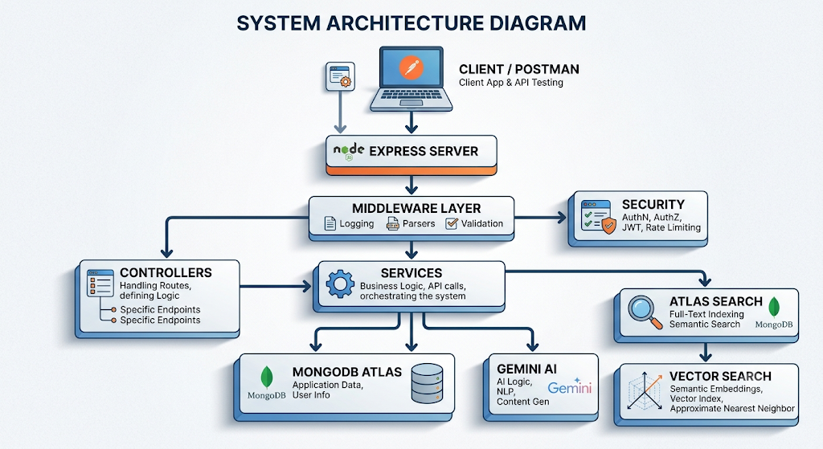
The BlogNest architecture includes an Express server gateway, authentication and role middleware, business services, a Mongoose database layer, and an AI flow connected to Gemini-based services.
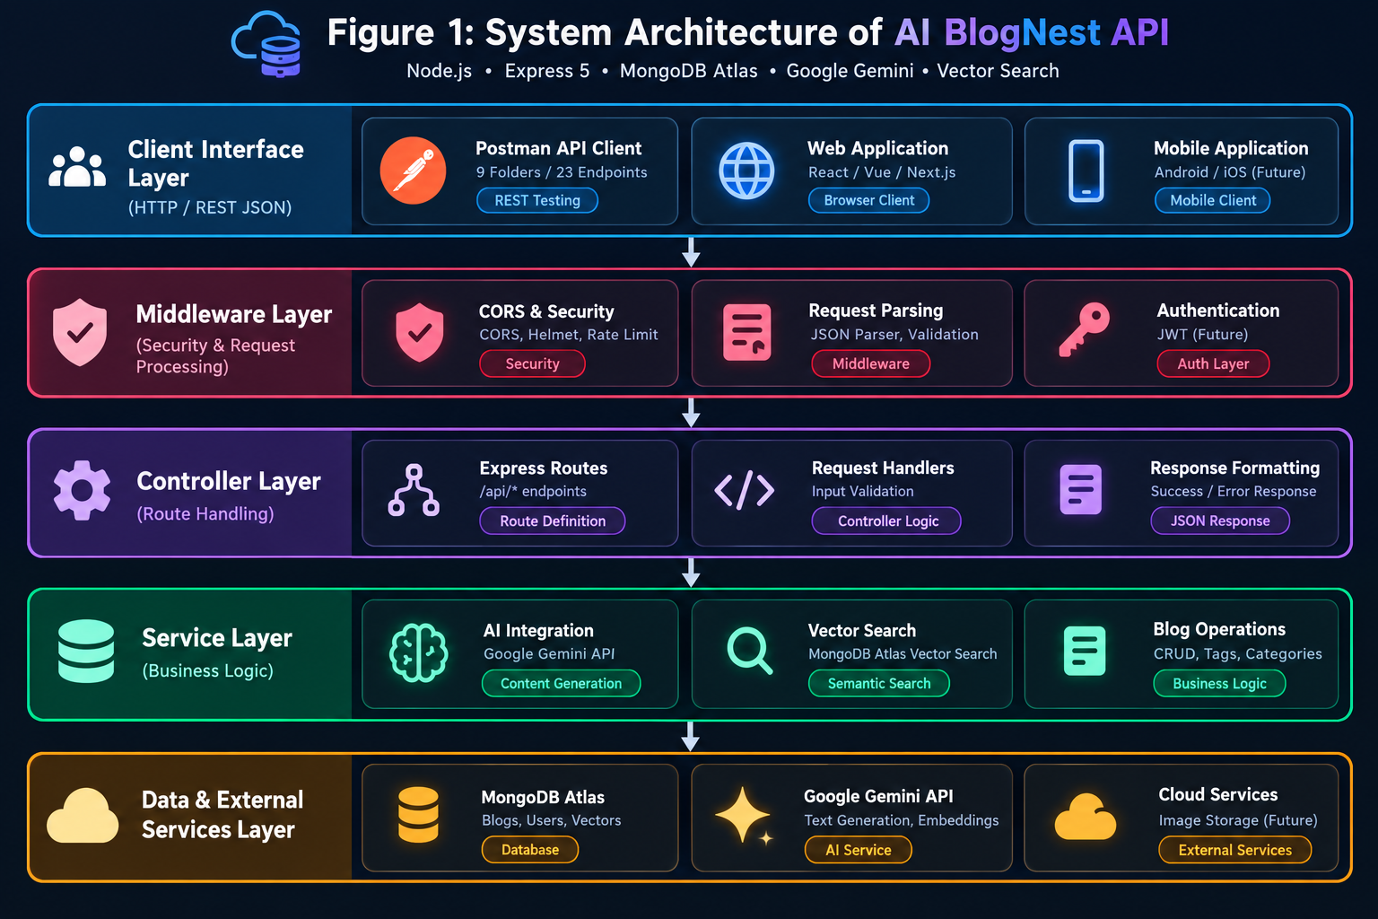
Figure 1: System Architecture of AI BlogNest API

12. MVC ARCHITECTURE
AI BlogNest follows the MVC design pattern with a service layer.

12.1 Model Layer
The Model layer defines the structure of the application's data.
Models include:
- User
- Blog
- Category
- Comment
- Embedding

12.2 Controller Layer
The Controller layer receives HTTP requests, processes parameters, calls appropriate services, and returns responses.
Controllers include:
- Authentication Controller
- User Controller
- Blog Controller
- Category Controller
- Comment Controller
- AI Controller
- Search Controller

12.3 Routing Layer
The Routing Layer defines the REST API endpoints and connects requests to controller functions.

12.4 Service Layer
The Service Layer contains business logic and external service integrations.
Services include:
- Blog Service
- Category Service
- Comment Service
- User Service
- Gemini Service
- Embedding Service
- Search Service
- Vector Search Service
The BlogNest specification describes Models, Controllers, and an API Routing Layer for the headless backend architecture.
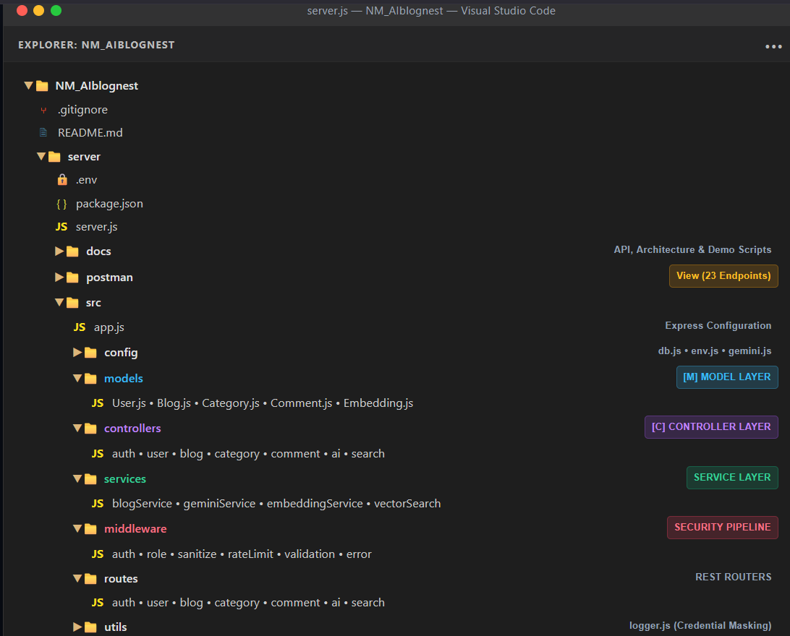

Figure 2: MVC-based project structure

13. DATABASE DESIGN
MongoDB Atlas is used as the primary database.
The main collections are:
Users
Blogs
Categories
Comments
Embeddings

14. USER ENTITY
The User entity stores information about registered users.
Field | Description
_id | Unique user identifier
name | User name
email | Unique email address
password | Hashed password
role | User access role
createdAt | Creation time
updatedAt | Last update time
The BlogNest project specifies _id, name, email, hashed password, and role, with Reader as the default role.

15. BLOG ENTITY
The Blog entity stores blog content.

Field | Description
_id | Blog identifier
userID | Author reference
name/title | Blog title
photo | Media information/path
message/content | Main blog content
likes | Number of likes
category | Blog category
tags | Search/filter tags
status | Blog lifecycle state
timestamps | Creation/update information

Blog Status
- Draft
- Pending
- Scheduled
- Published
The BlogNest specification defines these content lifecycle states.

16. CATEGORY ENTITY
The Category entity is used to classify blog content.

Fields
- Category ID
- Category Name
- Description
- Created Date
- Updated Date

17. COMMENT ENTITY
The Comment entity stores comments associated with blogs and users.

Fields
- Comment ID
- Blog ID
- User ID
- Comment Content
- Moderation Status
- Created Date
- Updated Date

Moderation States
- Pending
- Approved
- Spam
The BlogNest specification includes protected comment management and moderation.

18. EMBEDDING ENTITY
The Embedding entity stores vector representations associated with blog content.
It is used for semantic search with MongoDB Atlas Vector Search.
The vector represents the semantic characteristics of the blog content and allows related queries to retrieve conceptually similar content.

19. ENTITY RELATIONSHIP DIAGRAM
The main relationships are:
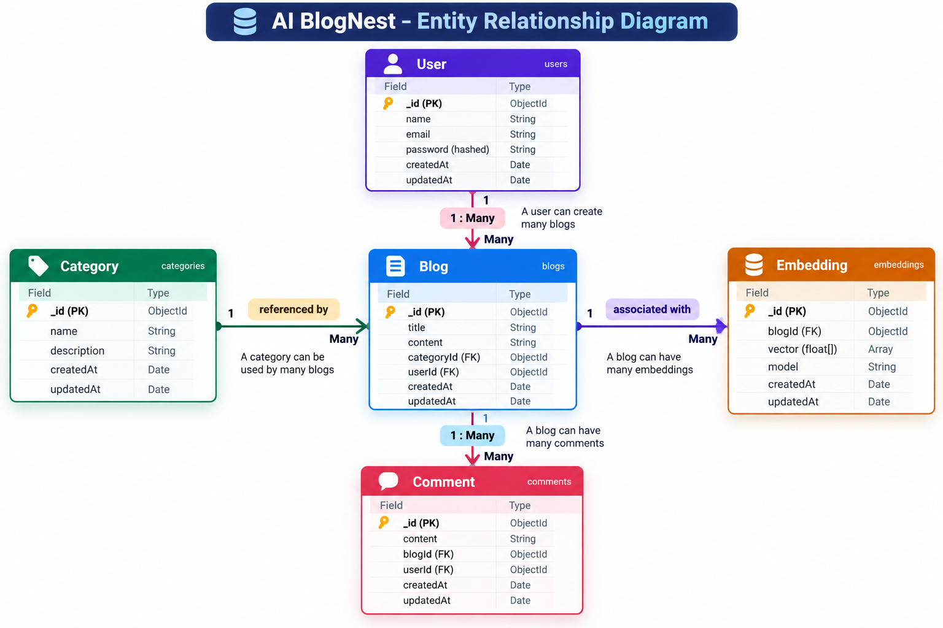

Relationship Explanation
- One user can create multiple blogs.
- One user can create multiple comments.
- One blog can contain multiple comments.
- A blog can belong to a category.
- A blog can have associated embedding data.
The BlogNest document describes the User-to-Post, User-to-Comment, and Post-to-Comment relationships.

20. USER ROLES AND RESPONSIBILITIES
AI BlogNest implements four user roles:

20.1 Admin
The Admin has the highest level of access and can manage users, roles, blogs, categories, and comment moderation.

20.2 Editor
The Editor reviews blog content, manages publishing workflows, manages categories, and moderates comments.

20.3 Author
The Author creates blog posts, manages their own posts, and uses AI-assisted content generation.

20.4 Reader
The Reader accesses published blogs, performs searches, and submits comments.
These four roles are specified in the AI BlogNest project requirements.
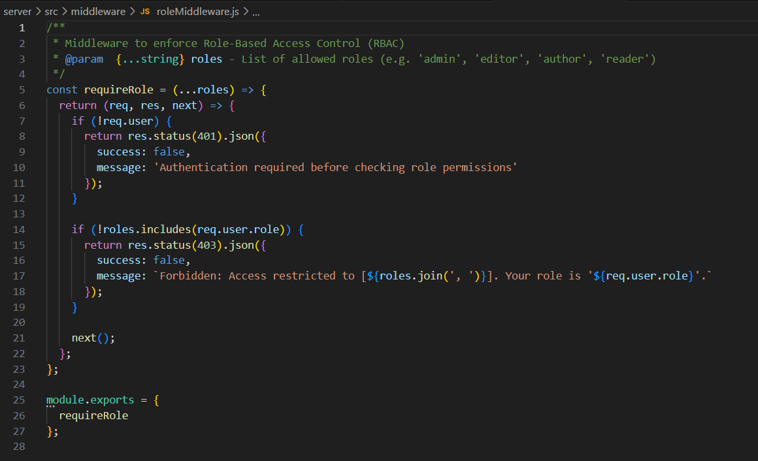
Figure 19: Role-based access control in AI BlogNest

21. ROLE-BASED ACCESS CONTROL
Role-Based Access Control (RBAC) restricts operations according to the authenticated user's role.
Operation | Admin | Editor | Author | Reader
Create Blog | ✓ | ✓ | ✓ | ✗
Update Own Blog | ✓ | ✓ | ✓ | ✗
Update Any Blog | ✓ | ✓ | ✗ | ✗
Delete Blog | ✓ | Limited | Own | ✗
Manage Categories | ✓ | ✓ | ✗ | ✗
Create Comment | ✓ | ✓ | ✓ | ✓
Moderate Comments | ✓ | ✓ | ✗ | ✗
Change User Role | ✓ | ✗ | ✗ | ✗
View Published Blogs | ✓ | ✓ | ✓ | ✓
The implemented project uses role middleware to enforce these permissions.

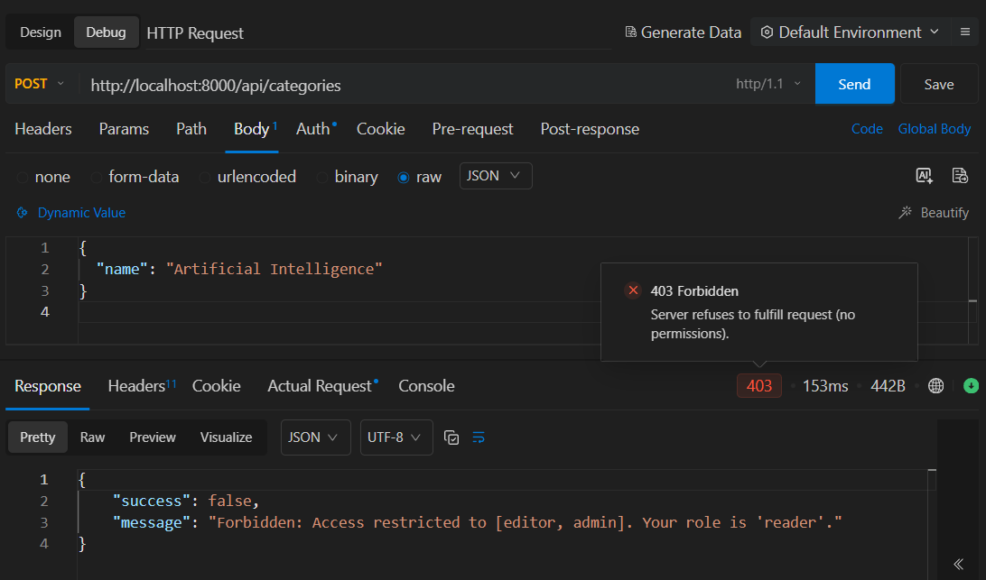

Figure 20: RBAC preventing unauthorized access

22. AUTHENTICATION AND JWT
AI BlogNest uses JWT-based authentication.

Registration
POST /api/auth/register
A new account is created and the password is securely hashed before storage.

Login
POST /api/auth/login
The system verifies the credentials and generates a JWT token.

Protected Requests
Authenticated requests use:
Authorization: Bearer <JWT_TOKEN>
The JWT identifies the authenticated user and allows protected operations to be accessed according to role permissions.
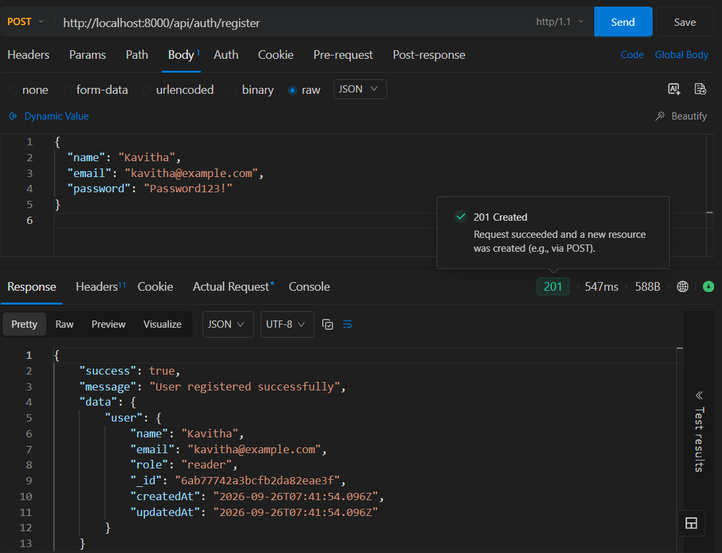
Figure 21: User registration
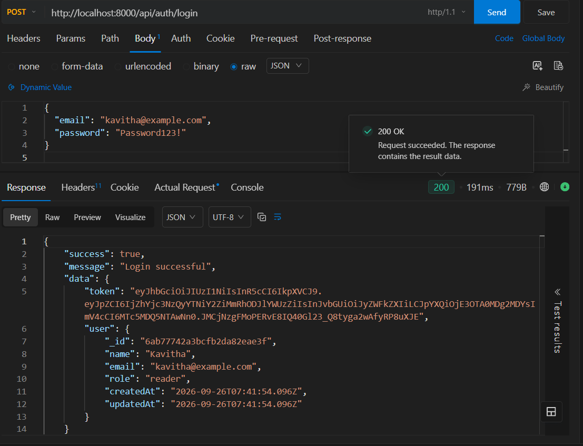
Figure 22: User login and JWT authentication
23. BLOG MANAGEMENT
AI BlogNest provides complete blog lifecycle management.

Blog APIs
POST /api/blogs
GET /api/blogs
GET /api/blogs/:id
PUT /api/blogs/:id
DELETE /api/blogs/:id
Blog posts support lifecycle states such as:
- Draft
- Pending
- Scheduled
- Published
Ownership protection ensures that authors can manage their own posts while elevated roles can perform broader operations.
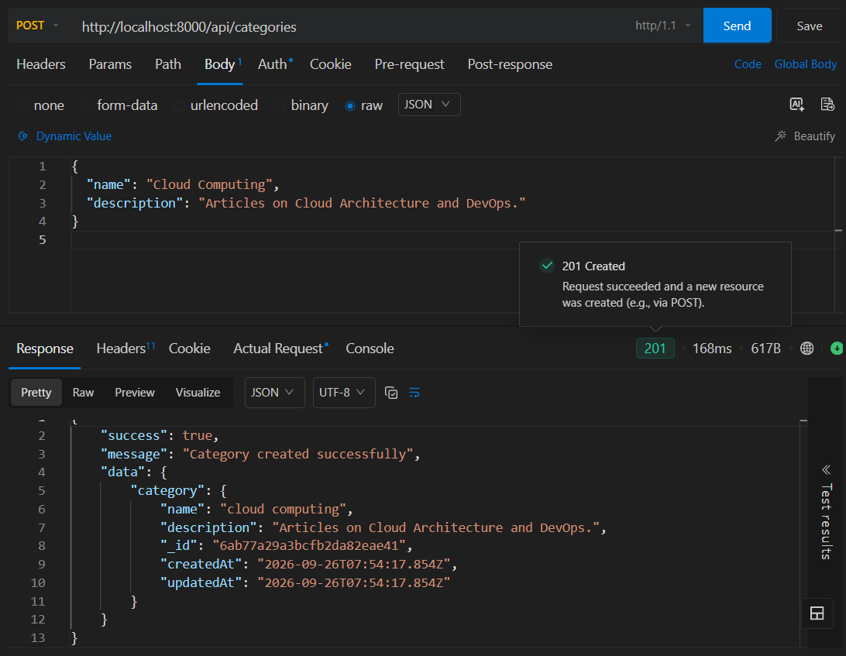
Figure 23: Creating a blog

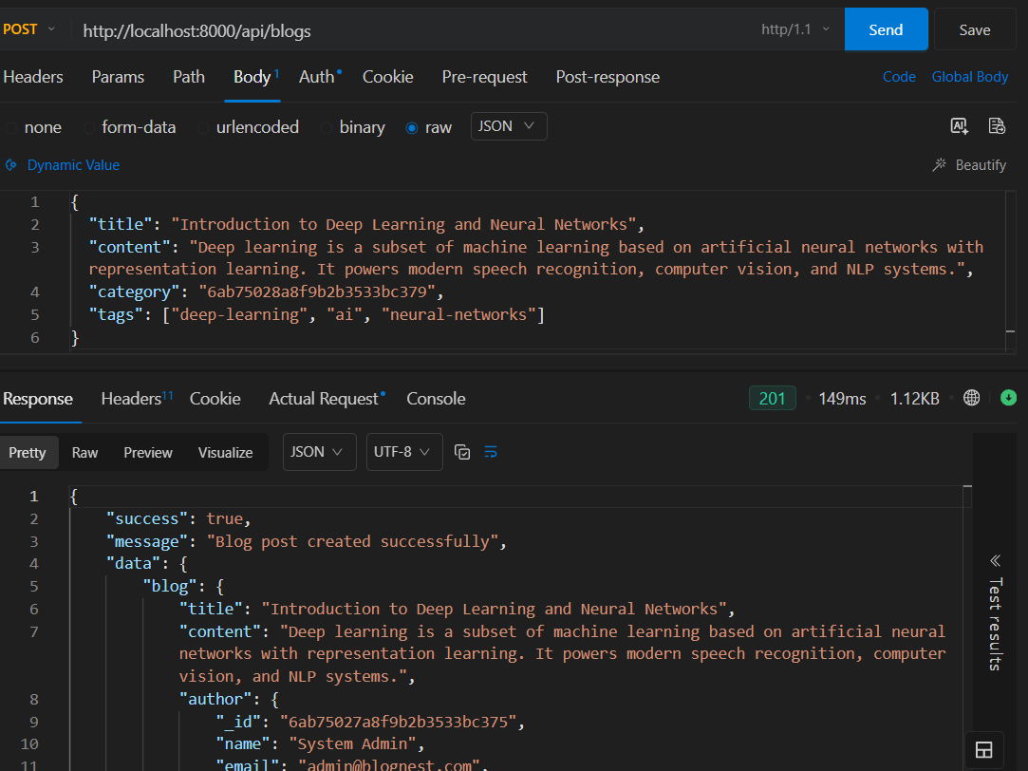
Figure 24: Retrieving blog posts
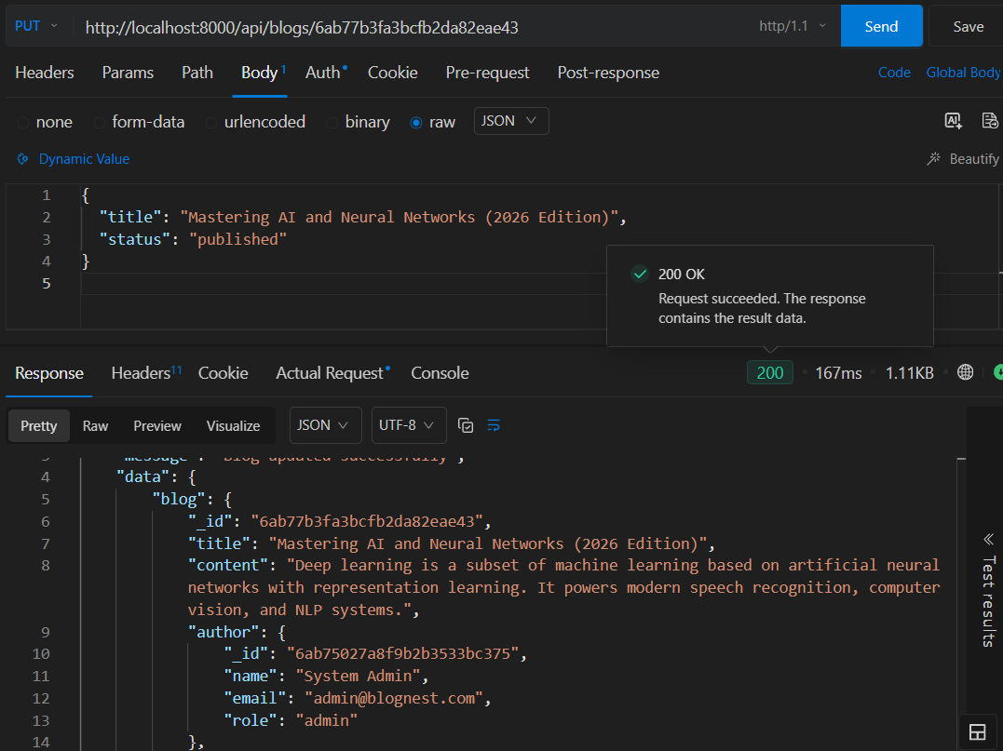
Figure 25: Updating a blog

24. CATEGORY MANAGEMENT
Categories are used to organize blog content.

APIs
POST /api/categories
GET /api/categories
GET /api/categories/:id
PUT /api/categories/:id
DELETE /api/categories/:id
Category management is protected through role-based authorization.
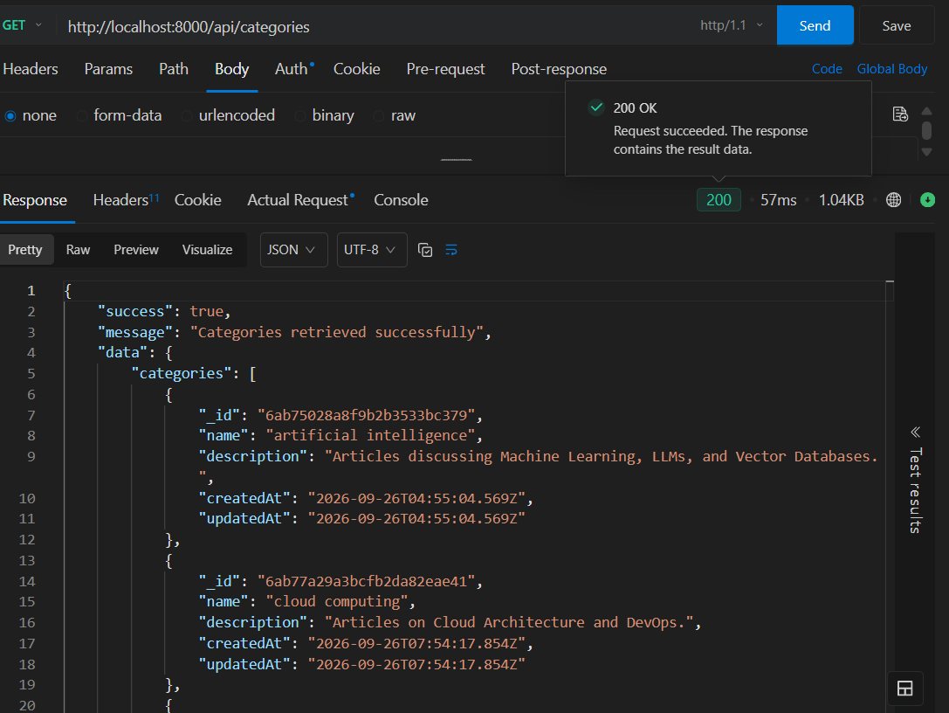
Figure 26: Category management

25. COMMENT MANAGEMENT AND MODERATION
Users can add comments to published blogs.

APIs
POST /api/blogs/:blogId/comments
GET /api/blogs/:blogId/comments
PUT /api/comments/:id
DELETE /api/comments/:id
Comments support moderation states:
- Pending
- Approved
- Spam
Authorized Editors and Administrators can moderate comments.
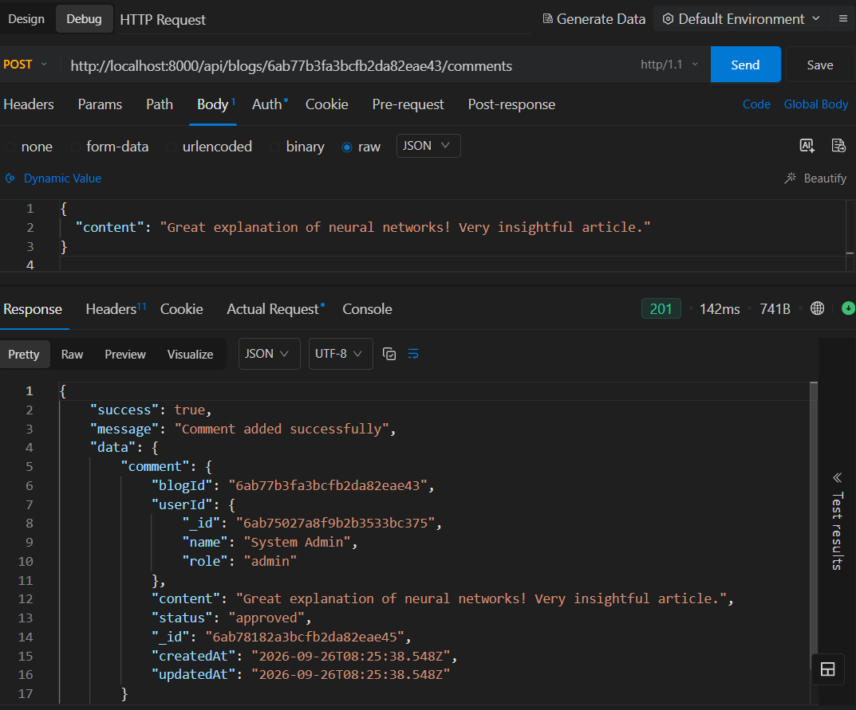
Figure 27: Creating a blog comment
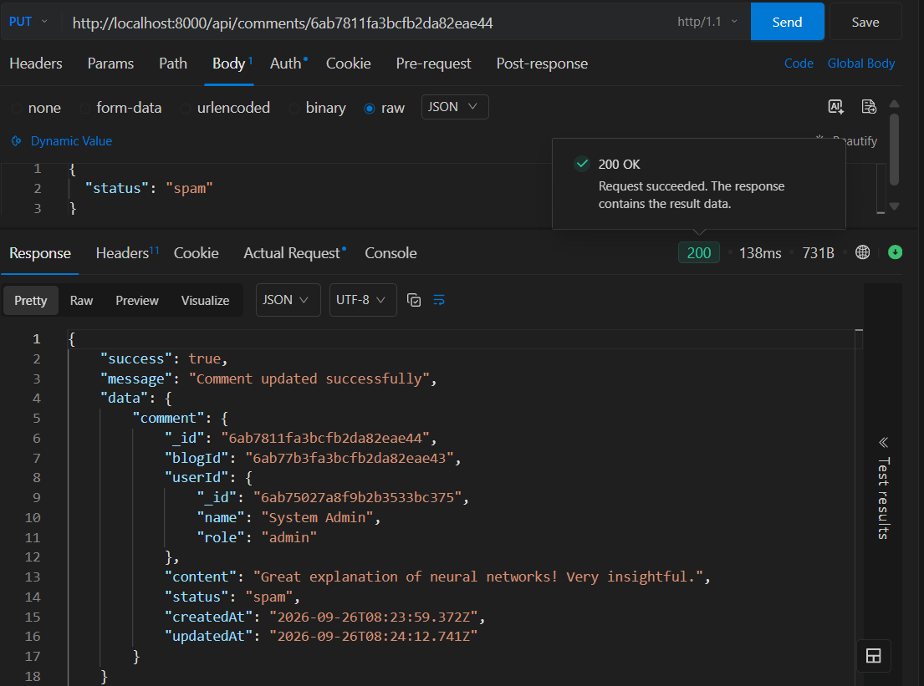
Figure 28: Comment moderation

26. GOOGLE GEMINI AI INTEGRATION
Google Gemini is used to provide AI-assisted blog content generation and summarization.
The project defines the following AI endpoints:
POST /api/ai/generate-blog
POST /api/ai/summarize
The BlogNest specification identifies AI blog generation and content summarization as core AI functions.
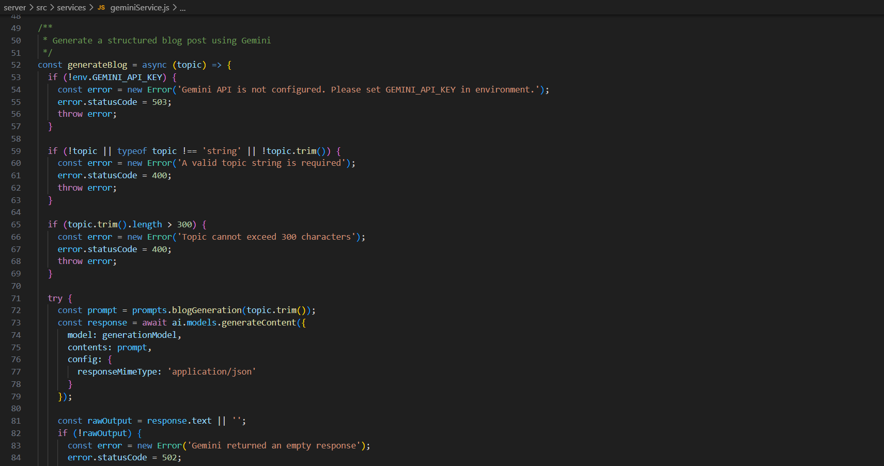

27. AI BLOG GENERATION
The AI blog-generation endpoint accepts a topic and generates structured blog content.

Request
{
"topic": "Artificial Intelligence in Education"
}

Response
The generated result contains structured blog information such as:
- Title
- Content
- Summary
- Tags
This feature reduces the manual effort involved in creating an initial blog draft.
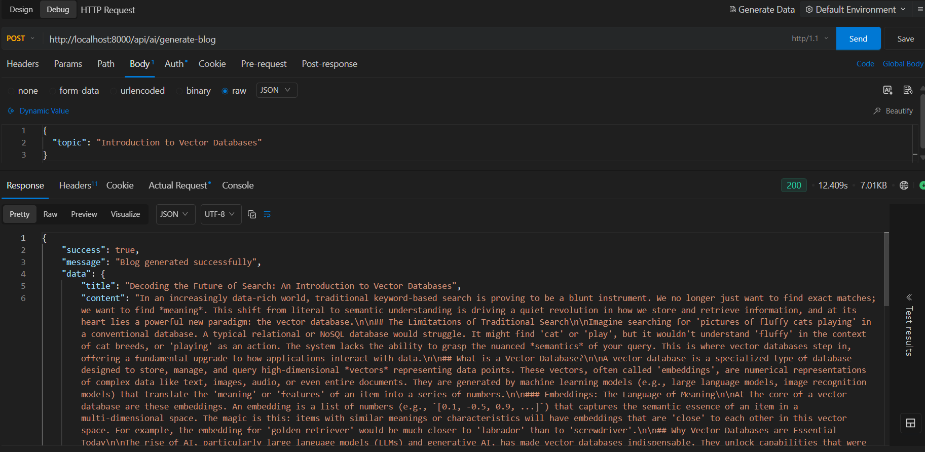
Figure 29: AI-powered blog generation using Google Gemini

28. PROMPT ENGINEERING
Prompt engineering is used to provide structured instructions to Google Gemini.

Processing Flow
Topic
↓
Structured Prompt
↓
Google Gemini
↓
Generated Blog Content
The prompt defines the expected content structure and guides Gemini to generate useful blog content, summaries, and tags.
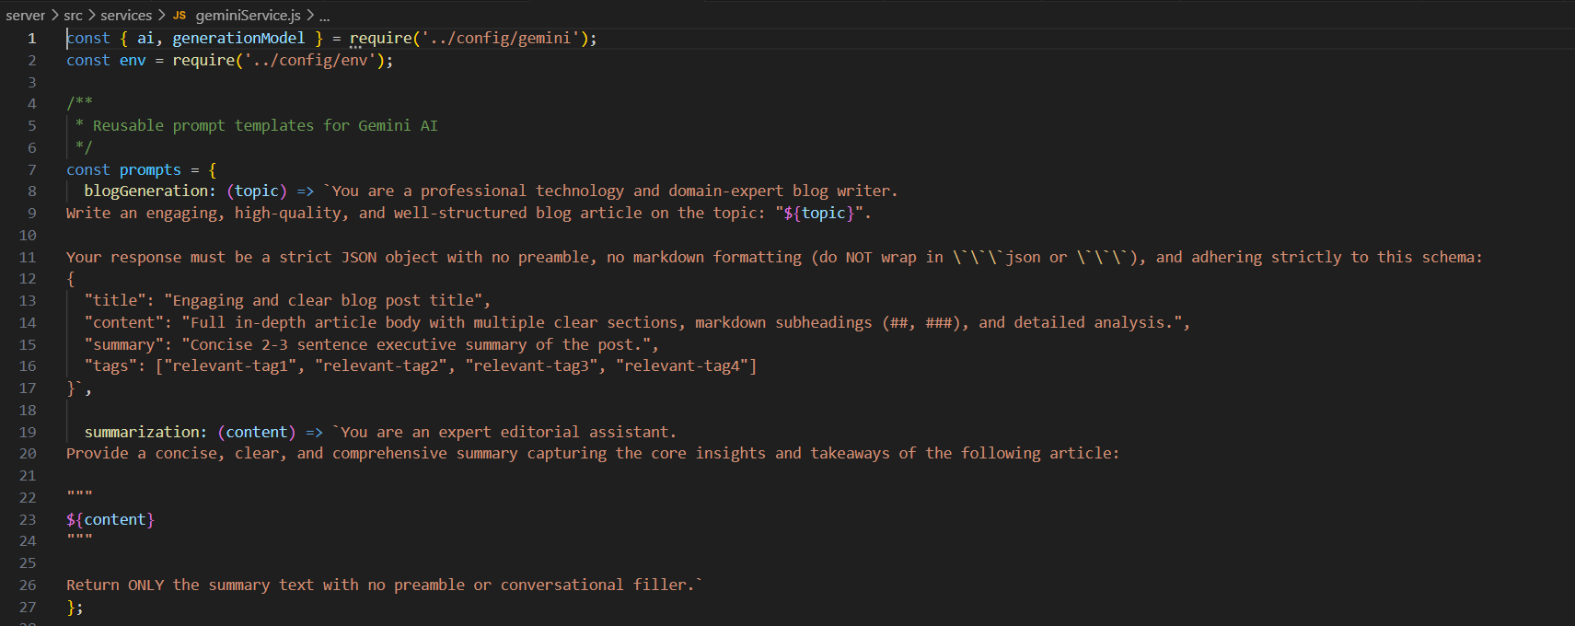
Figure 30: Prompt engineering for AI blog generation

29. AI BLOG SUMMARIZATION
The summarization endpoint generates a concise summary from blog content.

API
POST /api/ai/summarize

Input
{
"content": "Long blog content..."
}

Output
{
"summary": "Concise summary..."
}
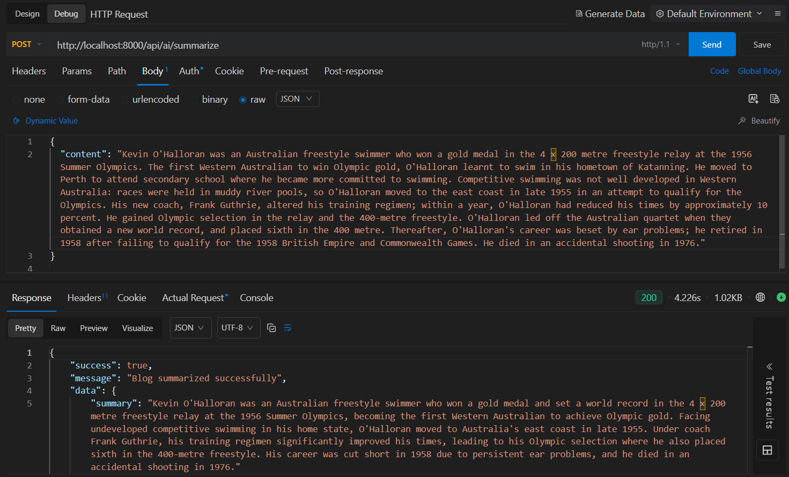
Figure 31: AI-powered blog summarization

30. MONGODB ATLAS SEARCH & VECTOR SEARCH INDEX

An Atlas Search index is configured for the blogs collection to support full-text searching.
The project uses the default search index for the blog collection.
MongoDB Atlas Vector Search is used to perform semantic search.
Blog content is converted into vector embeddings and stored in MongoDB. These vectors are indexed so that related content can be retrieved based on semantic similarity.

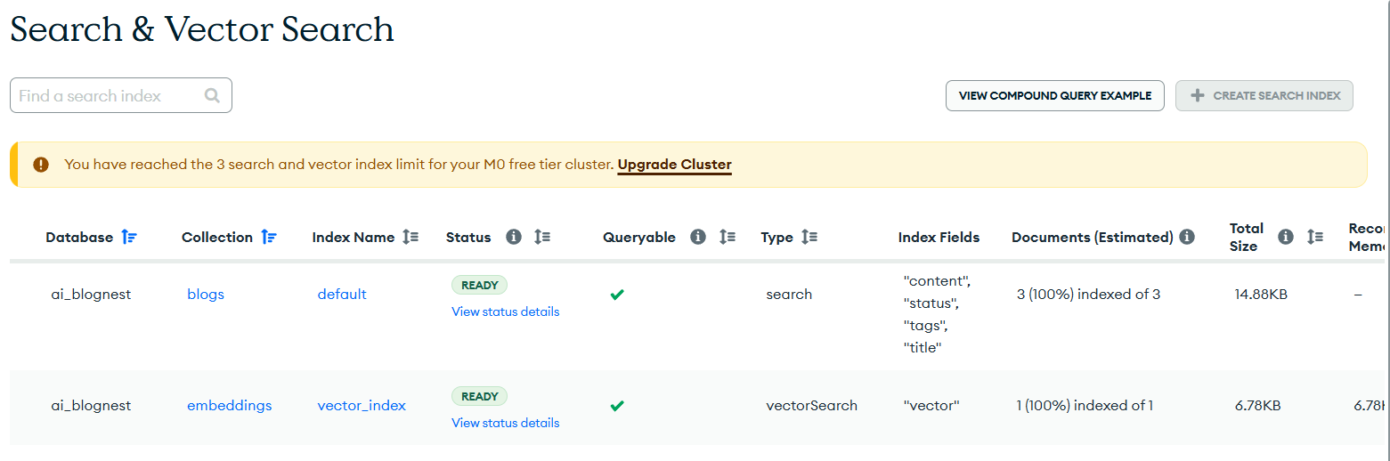

31. SEMANTIC SEARCH
Semantic search retrieves conceptually related blog content rather than relying only on exact keyword matches.

Processing Flow
The implemented project uses embedding vectors and Atlas vector search to retrieve semantically related blogs
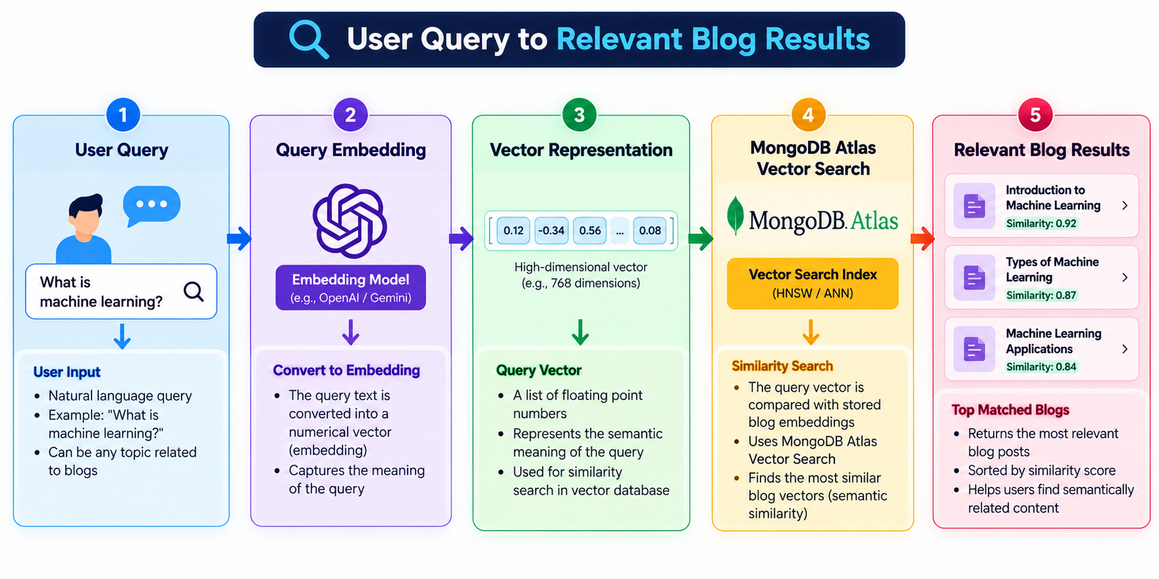.The implemented project uses embedding vectors and Atlas vector search to retrieve semantically related blogs.

API
GET /api/search/semantic?q=<question>
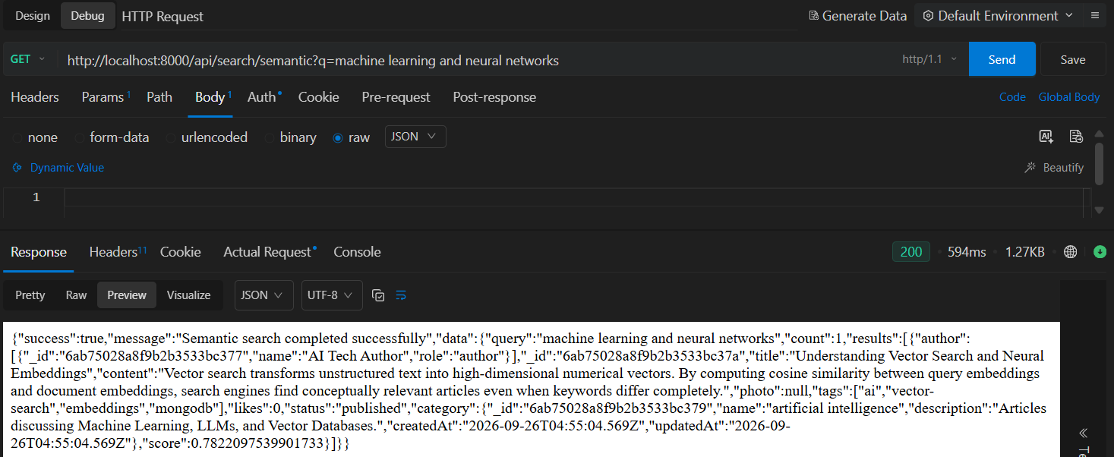
Figure 35: Semantic search using vector embeddings

32. MONGODB ATLAS SEARCH
MongoDB Atlas Search provides keyword-based full-text search across blog content.

API
GET /api/search?q=<search-term>
The search can use blog titles, content, and tags.
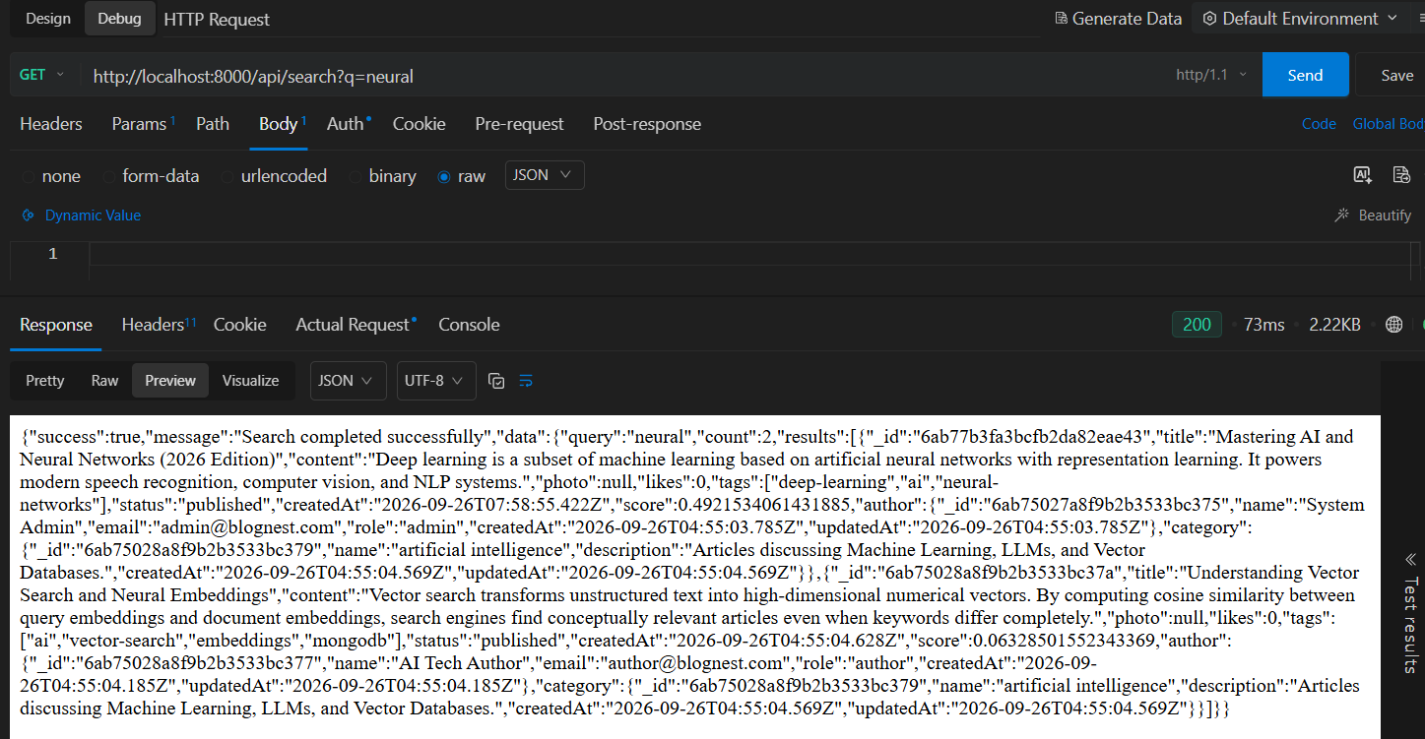
Figure 36: MongoDB Atlas Search result

33. SECURITY FEATURES
AI BlogNest implements the following security mechanisms:

Password Security
Passwords are hashed using bcrypt.

JWT Security
JWT tokens protect authenticated routes.

Role Authorization
RBAC prevents unauthorized operations.

Input Validation
Incoming request data is validated.

Input Sanitization
Potentially malicious input is sanitized.

Rate Limiting
Excessive requests are restricted.

Safe Error Handling
Internal implementation details are not exposed through API responses.

Sensitive Data Protection
Passwords and secret credentials are protected from exposure.
These security mechanisms are documented in the completed project.

34. API MODULE SUMMARY

Authentication

Method | Endpoint | Purpose
POST | /api/auth/register | Register user
POST | /api/auth/login | Login
POST | /api/auth/logout | Logout
GET | /api/auth/me | Current user
AI
Method | Endpoint | Purpose
POST | /api/ai/generate-blog | Generate blog
POST | /api/ai/summarize | Summarize blog

User
Method | Endpoint | Purpose
GET | /api/users | View users
GET | /api/users/profile | View profile
PUT | /api/users/:id | Update user
PATCH | /api/users/:id/role | Change role
Blog
Method | Endpoint | Purpose
POST | /api/blogs | Create blog
GET | /api/blogs | View blogs
GET | /api/blogs/:id | View individual blog
PUT | /api/blogs/:id | Update blog
DELETE | /api/blogs/:id | Delete blog
Category
Method | Endpoint | Purpose
POST | /api/categories | Create category
GET | /api/categories | List categories
GET | /api/categories/:id | View category
PUT | /api/categories/:id | Update category
DELETE | /api/categories/:id | Delete category
Comment

Method | Endpoint | Purpose
POST | /api/blogs/:blogId/comments | Add comment
GET | /api/blogs/:blogId/comments | View comments
PUT | /api/comments/:id | Update/moderate comment
DELETE | /api/comments/:id | Delete comment

Search
Method | Endpoint | Purpose
GET | /api/search?q= | Keyword search
GET | /api/search/semantic?q= | Semantic search

35. API TESTING
The backend APIs are tested using Postman/Thunder Client / EchoAPI for Vs code
The main testing sequence is:
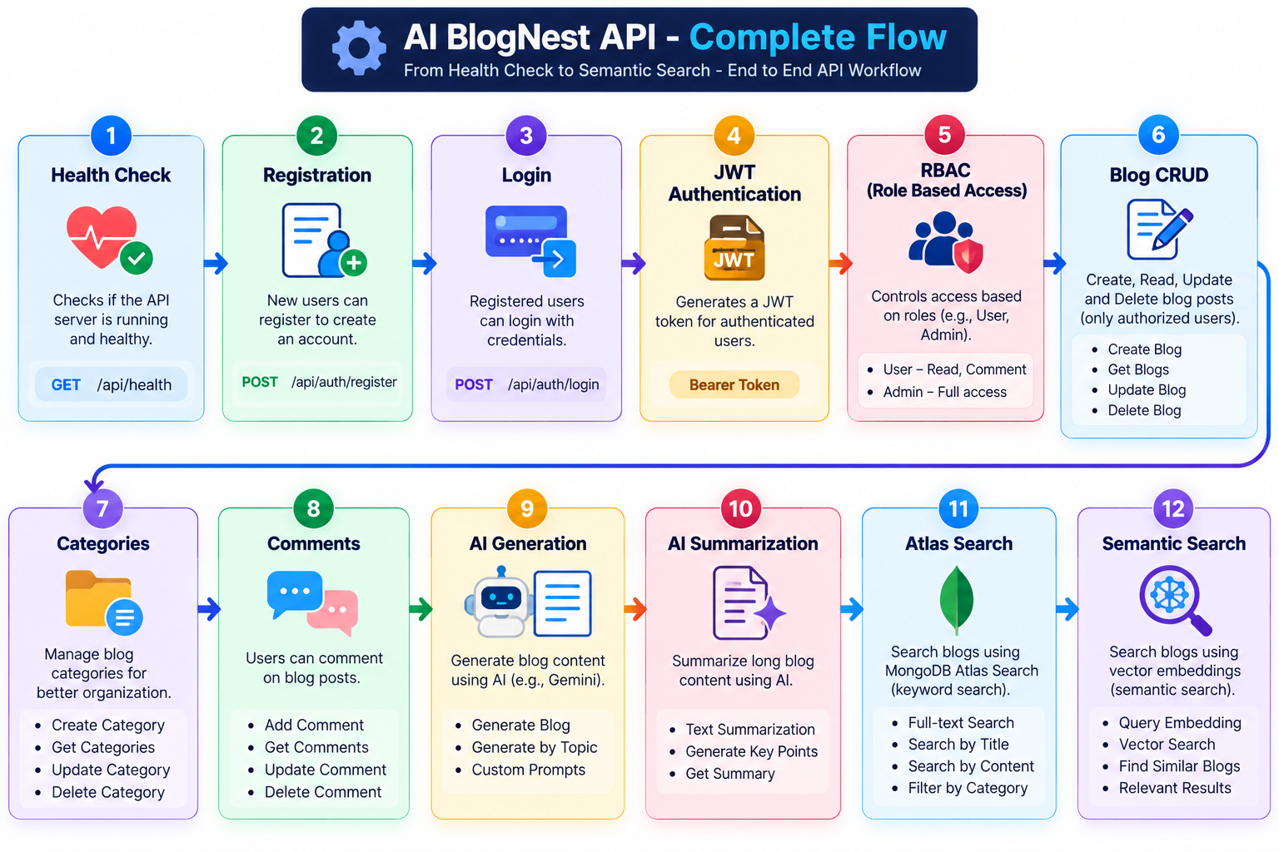

36. TESTING RESULTS
The completed testing verification tested authentication, roles, categories, blogs, comments, ownership protection, pagination, and filtering.
The reported result was:
25 Passed, 0 Failed.
For the final documentation, the latest overall project test result should be used.

37. MONGODB CONNECTION

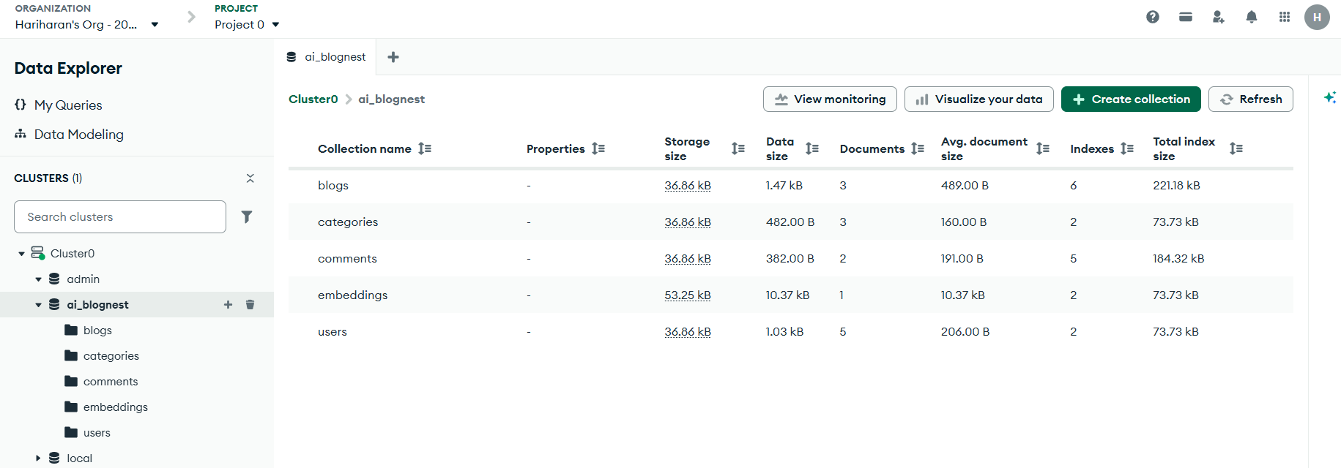

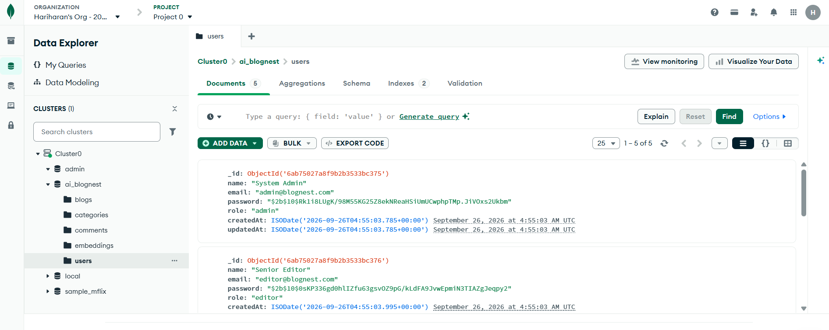

38. SYSTEM FUNCTIONALITY SUMMARY

Module | Main Functionality
Authentication | Registration, Login, JWT
Authorization | Admin, Editor, Author, Reader
Blog | Create, Read, Update, Delete
Category | Category management
Comments | Creation and moderation
Gemini AI | Blog generation and summarization
Atlas Search | Keyword search
Vector Search | Semantic search
Security | Validation, sanitization, rate limiting
Testing | Postman and automated testing

39. ADVANTAGES
- AI-assisted blog creation reduces manual content-generation effort.
- AI summarization provides concise versions of blog content.
- Role-based permissions control access to system operations.
- MongoDB Atlas Search supports keyword-based content discovery.
- Vector Search supports semantic content discovery.
- MVC architecture provides modular separation of application responsibilities.
- Postman enables direct backend API testing.

40. LIMITATIONS
- The current system is backend-focused.
- AI functionality depends on Google Gemini availability.
- Search functionality depends on MongoDB Atlas configuration.
- Semantic search quality depends on the generated embeddings and available blog content.
- A larger production deployment would require additional infrastructure.

41. FUTURE ENHANCEMENTS
The system can be extended with:
- Web-based frontend
- Rich text editor
- Advanced blog analytics
- Scheduled publishing
- Personalized recommendations
- AI-assisted SEO
- Automated content moderation
- Multi-language content generation

42. CONCLUSION
AI BlogNest API combines backend development, secure authentication, role-based authorization, database management, Generative AI, full-text search, and semantic vector search in a single REST API platform.
The system provides practical APIs for blog management and uses Google Gemini to assist with content generation and summarization. MongoDB Atlas Search and Vector Search improve blog discovery, while JWT and RBAC provide controlled access to system operations.
The project demonstrates the application of modern backend and AI technologies in an intelligent content-management system and satisfies the major functional and technical requirements defined for the TN Skills project.

